Name: _____________
AP Chemistry
Chapter 4 Practice Problems 2020

Multiple Choice
Identify the letter of the choice that best completes the statement or answers the question. Refer to your periodic table and formula sheet. Use of a calculator is NOT permitted for these questions!

____ 1. Commercial vinegar was titrated with NaOH solution to determine the content of acetic acid, HC₂H₃O₂. For 20.0 milliliters of the vinegar, 26.7 milliliters of 0.600–molar NaOH solution was required. What was the concentration of acetic acid in the vinegar if no other acid was present?

a. | 1.60 M | c. | 0.600 M
b. | 0.800 M | d. | 0.450 M

____ 2. It is suggested that SO₂ (molar mass = 64.1 grams), which contributes to acid rain, could be removed from a stream of waste gases by bubbling the gases through 0.25–molar KOH, thereby producing K₂SO₃. What is the maximum mass of SO₂ that could be removed by 1,000. liters of the KOH solution?
a. | 4.0 kg | c. | 16 kg
b. | 8.0 kg | d. | 20. kg

____ 3. Correct procedures for a titration include which of the following?
I. Draining a pipet by touching the tip to the side of the container used for the titration
II. Rinsing the buret with distilled water just before filling it with the liquid to be titrated
III. Swirling the solution frequently during the titration

a. | I only | d. | II and III only
b. | II only | e. | I, II and III
c. | I and III only

Free Response Questions
You may use your calculator, formula sheet and periodic table.

4. A 0.150 g sample of solid lead(II) nitrate is added to 125 mL of 0.100M sodium iodide solution. Assume no change in volume of the solution. The chemical reaction that takes place is represented by the following equation. (2008B)

Pb(NO₃)₂(s) + 2 NaI(aq) → PbI₂(s) + 2 NaNO₃(aq)

a) List an appropriate observation that provides evidence of a chemical reaction between the two compounds. (1 pt)

b) Calculate the number of moles of each reactant. (2 pts)

c) Identify the limiting reactant. Show calculations to support your identification. (2 pts)

d) Calculate the molar concentration of NO₃⁻(aq) in the mixture after the reaction is complete. (2 pts)

e) Circle the diagram below that best represents the results after the mixture reacts as completely as possible. Explain the reasoning used in making your choice. (2 pts)

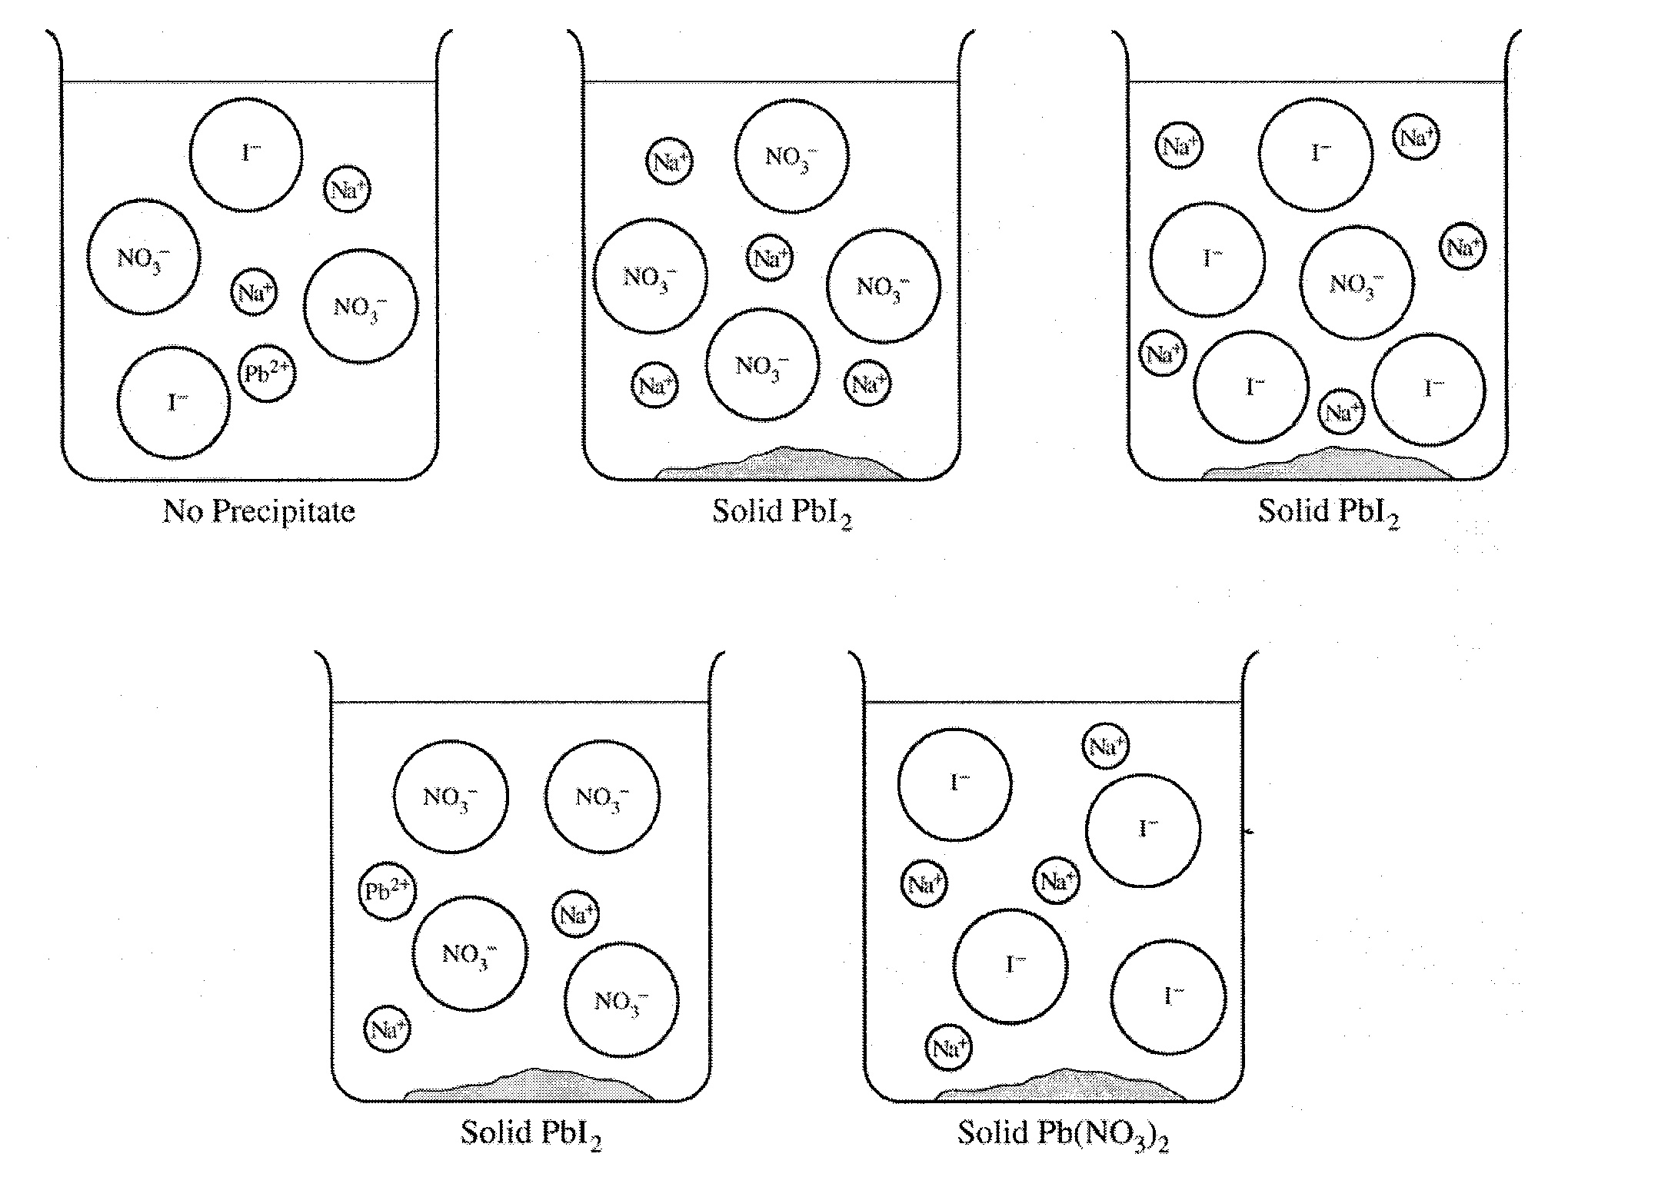

2004B
An experiment is performed to determine the molar mass of an unknown monoprotic acid, HA, a white solid, by titration with a standardized NaOH solution.

5. a) What measurement(s) must be made to determine the number of moles of NaOH used in the titration? (1 point)

b) Write a mathematical expression that can be used to determine the number of moles of NaOH used to reach the endpoint of the titration. (1 pt)

c) In addition to the measurements made in the previous questions, what other measurement(s) must be made to determine the molar mass of the acid, HA? (1 pt)

d) Write the mathematical expression that is used to determine the molar mass of HA. (1 pt)

e) The following diagram represents the setup for the titration. In the appropriate boxes below, list the chemical(s) needed to perform the titration. (3 points)
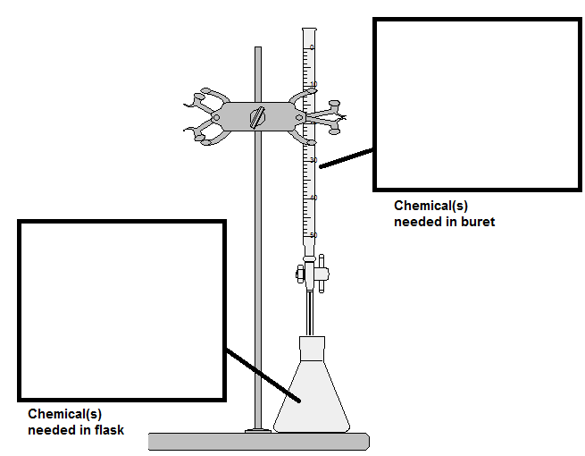

f) Explain what effect each of the following would have on the calculated molar mass of HA. Justify your answers.
i) The original solid acid, HA, was not completely dry at the beginning of the experiment. (1 pt)

ii) The procedure called for 25 mL of water in the Erlenmeyer flask, but a student used 35 mL of water. (1 point)

.

.

6. 1989 A
In an experiment to determine the molar mass for ascorbic acid (vitamin C), a student dissolved 1.3717 grams of the acid in water to make 50.00 milliliters of solution. The entire solution was titrated with a 0.2211 molar NaOH solution. The pH was monitored throughout the titration. The equivalence point was reached when 35.23 milliliters of the base has been added. Under the conditions of this experiment, ascorbic acid acts as a monoprotic acid that can be represented as HA.
(a) From the information above, calculate the molar mass of ascorbic acid. (2 pts)

