AP Chemistry
Summer assignment 2020

This assignment is all review material from Honors Chemistry.
If your textbook hasn’t arrived yet, or you are interested in digital texts, this is a convenient and reliable text https://openstax.org/books/chemistry-2e/pages/1-introduction
You may also find my webcasts at https://www.youtube.com/user/kvanderveen to be a useful resource.

- Memorize the polyatomic ions. I recommend making flash cards or a Quizlet set.
- Join the Bromfield AP chemistry group on Facebook.
- CALM Review problem set due 8/25
http://calm.indiana.edu/
I will email your username and password to you individually.
Sig figs, dimensional analysis
Names, formulas
Balancing equations
Compositional stoichiometry
Reaction Stoichiometry

You must complete this CALM assignment before 10 pm on Tuesday, August 25th. Don’t wait until the last minute to get started! This assignment will be checked on line and will be considered your first quiz of the course.

- Complete the following practice questions. You will submit this the first day of classes. The topic numbers are based on the current course and exam description from the College Board.

Topic 1.2 Mass Spectroscopy

- Explore the Mass Spectrometer Learning Tool at https://isotopesmatter.ca/lessons/3_1.html

    - List the y axis and the x axis labels.

    - Explain why the peaks in the mass spectrometer have different amplitudes.

    - State the identities of unknown elements 1 and 2.

- An element is composed of three stable isotopes, A₁, A₂, and A₃. Isotope A₁ is found 15% of the time, isotope A₂ is found 65% of the time, and isotope A₃ is found 20% of the time. The atomic mass units of A₁, A₂, and A₃ are 50.0, 52.0, and 53.0 respectively.
  - Draw a mass spectrum of the element.
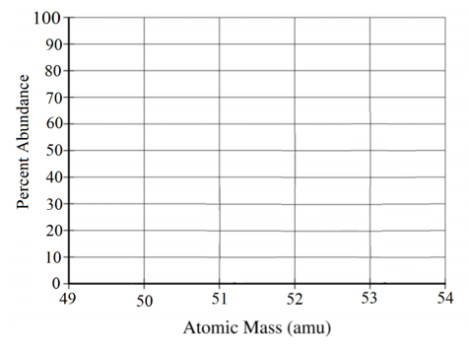
  - Determine the atomic mass of the element. Show the setup for your calculation.

  - The atomic number of fictitious element A is 27.
a) How many protons does A₃ have?
b) How many neutrons does A₃ have?

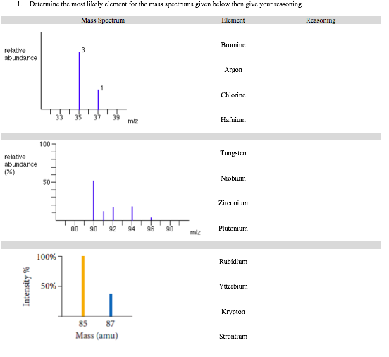
3.

Topics 1.3 & 1.4 Elemental Composition, Pure Substances & Mixtures

- Determine if the following substances are made of molecules, atoms, or ions by placing an “X” in the appropriate box.
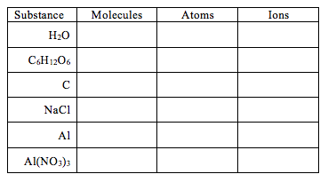
- Explain how to calculate the empirical formula of a compound when given …
- Grams of each element in the compound.

- Moles of each element in the compound.

- Percentage of each element in the compound.

- Determine the percent composition of every element in each compound. First, estimate the percentage without a calculator, then check your work with a calculator.
- SF₄

- SF₆

- Perform the following calculations without a calculator. Then, check your work with a calculator.
- A 66.0 g sample of a compound contains 36.0 g of C, 6.00 g of H, and 24.0 g of O. Determine the empirical formula.

- A compound contains 0.75 moles of K, 0.75 moles of Cr, and 5.25 moles of O. What is the simplest formula of the compound?

- A compound is made of 12.67% Al, 19.73% N, and 67.60% O. Determine the empirical formula of the compound.

- An organic compound, containing only C, H, and O, is analyzed via combustion analysis. A 1.875 g sample of the compound is combusted and 3.834 g of CO₂(g) and 1.177 g of H₂O(l) is collected. Determine the empirical formula of the compound.

- A hydrocarbon undergoes combustion analysis to determine the empirical formula of the compound. After complete combustion it is determined that there are 66 g of CO₂ and 36 g of H₂O.
- Determine the empirical formula without using a calculator.

- Confirm your answer using a calculator.

- A student is given a mixture of NaCl(s) and NaNO₃(s) and is tasked with determining the percent of NaCl in the mixture. The student dissolves 3.613 g of the mixture in 50 mL of distilled water. The student then adds excess AgNO₃(aq) to precipitate the chloride ion as AgCl(s). The student determines that 2.268 g of AgCl is formed.
- Determine the moles of NaCl in the original mixture.

- Determine the percent by mass of NaCl in the original mixture.

- In an experiment, a student is assigned the task of determining the number of moles of water in one mole of the hydrate Na₂SO₄ • nH₂O. The student collects the data shown in the following table.

Mass of empty container | 22.347 g
Initial mass of sample and container | 25.959 g
Mass of sample and container after first heating | 24.677 g
Mass of sample and container after second heating | 23.941 g
Mass of sample and container after third heating

- Explain why the sample was heated three times.

- Explain why the student can conclude that all of the water was driven off of the hydrate.

- Use the data above to …
      - Determine the mass of the sample before heating.

      - Determine the mass of water in the sample.

      - Determine the moles of water in the sample.

    - Determine the mass of the anhydrous salt in the sample.

    - Determine the moles of the anhydrous salt in the sample.

    - Determine the formula of the hydrated compound.

- In an experiment, a student is assigned the task of determining the number of moles of water in one mole of the hydrate CuSO₄ • nH₂O. The student collects the data shown in the following table.

Mass of empty container | 22.347 g
Initial mass of sample and container | 25.959 g
Mass of sample and container after first heating | 25.700 g
Mass of sample and container after second heating | 25.046 g
Mass of sample and container after third heating | 25.045 g

- Use the data above to …
      - Determine the mass of water in the sample.

      - Determine the moles of water in the sample.

      - Determine the formula of the hydrated compound.

- Determine if the calculated mass of the water would increase, decrease, or remain the same if …
- while heating the substance, some solid spattered out. Explain your reasoning.

- after heating the hydrate completely it was left out on the counter for an entire
day before the final weighing. Explain your reasoning.

- the sample was heated too long and some of the anhydrous salt vaporized and
left the container. Explain your reasoning.

- Answer the following questions about different mixtures of chloride compounds.
- A mixture of NaCl and KCl are in a container. The percent of chloride in NaCl is 60.6%. Would the percent of chloride in the mixture be greater than, less than, or equal to the percent of chloride in NaCl? Explain your reasoning.

- A mixture of NaCl and LiCl are in a container. The percent of chloride in NaCl is 60.6%. Would the percent of chloride in the mixture be greater than, less than, or equal to the percent of chloride in NaCl? Explain your reasoning.

- Determine if the following impurities would increase, decrease, or not change the percent of carbon in a mixture with C₆H₁₂O₆, which is about 40% carbon by mass.
  - Water, H₂O

  - Ribose, C₅H₁₀O₅

  - Fructose, C₆H₁₂O₆ (an isomer of glucose)

  - Sucrose, C₁₂H₂₂O₁₁

- Perform the following calculations. First, do it without a calculator, then check your answer with a calculator.
- How many grams of Cu are in 0.010 moles of CuSO₄?

ii. How many moles are in 1.80 grams of C₆H₁₂O₆ (MM = 180 g/mol)?

- What is the percent composition of Ca in CaF₂?

Topic 4.5 Reaction Stoichiometry

Attempt the following questions without a calculator first. Then, check your work with a calculator.

- According to the balanced equation below, how many moles of HI would be necessary to produce 2.5 mol of I₂, starting with 4.0 mol of KMnO₄ and 3.0 mol of H₂SO₄?

10 HI + 2 KMnO₄ + 3 H₂SO₄ → 5 I₂ + 2 MnSO₄ + K₂SO₄ + 8 H₂O

- According to the reaction represented below, about how many grams of aluminum (atomic mass 27 g) are necessary to produce 0.50 mol of hydrogen gas at 25 ℃ and 1.00 atm?

2 Al_{(s)} + 6 HCl_{(aq)} → 2 AlCl_{3(aq)} + 3 H_{2(g)}

- According to the balanced equation below, how many moles of ClO₂–_{(aq)} are needed to react completely with 20. mL of 0.20 M KMnO₄ solution?

2 H₂O(l) + 4 MnO₄ –_{(aq)} + 3 ClO₂ –_{(aq)} → 4 MnO_{2(s)} + 3 ClO₄ –_{(aq)} + 4 OH –_{(aq)}
(Hint: review the molarity formula)

- Acetic acid and sodium hydrogen carbonate are reacted and the gas is collected.

HC₂H₃O_{2(aq)} + NaHCO_{3(s)} → NaC₂H₃O_{2(aq)} + H₂O_{(l)} + CO_{2(g)}

- Determine the volume of CO₂ produced when 2.50 g of NaHCO₃ reacts with 55.0 mL of 0.875 M acetic acid at STP.
(Hint: PV = nRT for gases)
ii. What mass of sodium bicarbonate is required to produce 19.0 L of carbon dioxide gas at 20.0 ℃ and 1.2 atm of pressure?

Extra Credit Opportunity: Read Uncle Tungsten by Oliver Sacks, The Poison Squad by Deborah Blum or The Radium Girls by Kate Moore. Write a short summary of the most memorable events of the book and what you enjoyed about the book. You will receive an extra 5% on your first test grade if this is handed in on the first day of school.

