AP Chemistry

Enthalpy of Formation Problems

In a formation reaction, one mole of the substance is synthesized from its elements in their standard states. The enthalpy change of such a reaction is the “enthalpy of formation.”

Ex. H₂(g) + ½ O₂(g) → H₂O(l) ${∆H}_{f}^{o}$ = -285.9 kJ

What are the 2 hallmarks of formation reactions?

We can use enthalpy of formation data to find the enthalpy of reactions. You will be given enthalpy of formation data, but you are expected to know that free elements in their standard state have zero enthalpy. Here is the equation that we use:

$∆H_{rxn}^{o}$= Σn${∆H}_{f}^{o}$ _{(products)} – Σm${∆H}_{f}^{o}$_{(reactants)}

where n represents the coefficients for the products, and
m represents the coefficients for the reactants.

This all works because enthalpy is a state function: $∆H_{rxn}^{o}$depends only on the initial and final state of the reaction, not how you got from one to the other.

1. Which of the following are formation reactions? If a reaction is not a formation reaction, explain whyl

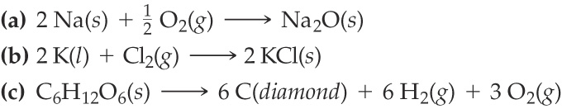

Compound | $${∆H}_{f}^{o} (kJ/mol)$$
CH₄(g) | -74.8
H₂O(l) | -285.8
H₂O(g) | -241.8
CO₂(g) | -393.5
C₄H₁₀(g) | -125.6

2. Use enthalpy of formation data to find ${∆H}_{rxn}^{o}$ for the following reaction:
CH₄(g) + 2 O₂(g) → CO₂(g) + 2 H₂O(g)

3. Use enthalpy of formation data to find ${∆H}_{rxn}^{o}$ for the following reaction:
2 C₄H₁₀(g) + 13 O₂(g) → 8 CO₂(g) + 10 H₂O(g)

Compound | $${∆H}_{f}^{o} (kJ/mol)$$
CH₄(g) | -74.8
H₂O(l) | -285.8
H₂O(g) | -241.8
CO₂(g) | -393.5
MgCl₂(s) | -641.8
NaOH(aq) | -469.15
NaCl(aq) | -407.27
Mg(OH)₂(s) | -924.54

4. Find the standard enthalpy of reaction for the reaction between solid magnesium chloride and a solution of sodium hydroxide. (Remember to start with a balanced equation!)

5. Consider the following reaction: CuO(s) + H₂(g) → Cu(s) + H₂O(l) ${∆H}_{rxn}^{o}$ = -129.7 kJ
Calculate ${∆H}_{f}^{o}$ for CuO(s).

Key
2. -802.3 kJ/mol
3. -5314.8 kJ/mol
4. -159 kJ
5. -156.1 kJ/mol

