Determining the Molar Enthalpy  
of Solution of a Salt

Dissolving salts in water involves an exchange of heat energy; in some cases, the heat transfer can be quite dramatic! This heat transfer is called the enthalpy of solution, ΔHsoln. ΔHsoln may be endothermic or exothermic, depending on two factors:

1. the energy required in breaking the bonds of the crystal lattice into its ions (endothermic)
2. the energy released when the ions are attracted to water molecules (exothermic)

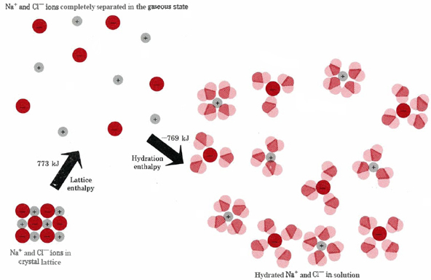Figure 1 below shows the process for sodium chloride:

Figure 1: The energetics of the solution process for sodium chloride

Source: Chem Education Digital Library

This can also be represented as an enthalpy diagram, as shown in Figure 2:

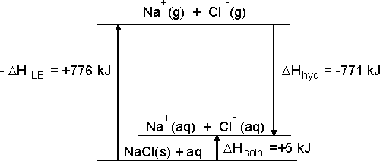

Figure 2: An enthalpy diagram for dissolving sodium chloride in water

The value of the enthalpy of solution can be positive, as shown for sodium chloride in Figure 2, or it can be negative. It is generally not possible to directly measure the heat energy change of the reactants and products (the system). We can measure the heat change that occurs in the surroundings by monitoring temperature changes. If we conduct a reaction between two substances in aqueous solution, then the enthalpy of the solution can be indirectly calculated with the following equation.

*q* = *Cp* × *m* × ∆*T*

The term *q* represents the heat energy that is gained or lost. *Cp* is the specific heat of water, *m* is the mass of the solution, and ∆*T* is the temperature change of the reaction mixture. The specific heat and mass of water are used because water will either gain or lose heat energy in a reaction that occurs in aqueous solution. It is possible to determine the enthalpy per mole of salt dissolved using this data.

In this experiment, you will design and carry out an experiment to determine the enthalpy of solution, Δ*Hsoln/mol* of a solid. You will use a styrofoam cup nested in a beaker as a calorimeter, as shown in Figure 3. For purposes of this experiment, you can assume that heat loss to the calorimeter is negligible.

Figure 3

OBJECTIVES

In this experiment, you will

* Design an experiment to determine the molar enthalpy of solution
* Experimentally determine the molar enthalpy of solution for a salt

AVAILABLE MATERIALS

|  |  |
| --- | --- |
| LabPro or CBL 2 interface  ring stand |  |
| Thermometer or Temperature Probe  Distilled water  Weighing paper or boats | Ammonium nitrate, ammonium chloride, potassium chloride, calcium chloride,  sodium acetate or other salts as available |
| Styrofoam cups  glass stirring rod |  |
| 50 mL or 100 mL graduated cylinders |
| 250 mL or 400 mL beaker |  |

PLANNING THE EXPERIMENT

As a lab group, discuss the following leading questions. You do not need to write out your answers for questions 1-7.

1. What information (data) is needed to calculate the heat change when the salt is dissolved in water?
2. Which salt will you use?
3. How much water will you use? How much salt will you use?
4. What will you need to measure?
5. How will you determine the number of moles of salt you used?
6. Will you need to repeat any trials?
7. What should you do if you realize that not all of your salt dissolved at the end of a trial?
8. Write out a step-by step procedure and consult with your instructor. Incorporate any suggested changes to your plan and design an appropriate data table in your lab notebook before starting the experiment.

CONDUCTING THE EXPERIMENT

1. Obtain and wear goggles and lab aprons. CAUTION: Some of the salts may be skin or eye irritants. Check all labels before proceeding. Sodium hydroxide is corrosive; take caution not to touch the pellets.
2. Carry out the procedure as planned. Record all relevant data and observations directly into your lab notebook. If you made any changes to your original plan, note the changes in your lab notebook.
3. Dispose of all solutions as directed by your instructor.
4. Use your data to determine the experimental molar enthalpy of solution.
   1. Calculate the amount of heat energy, *q*, produced in each trial. Use the specific heat of water, 4.18 J/(g•°C), for all solutions.
   2. Calculate the enthalpy change, ∆*H*, for each reaction in terms of kJ/mol of the salt in each trial.
   3. Calculate the average Δ*Hsoln* for your salt.
   4. Report the estimated standard deviation for each trial.

**ANALZYE AND APPLY**

1. Was dissolving your salt an endothermic or exothermic process? Explain how you determined this.
2. What measurement(s) limited your precision in this experiment? Explain.
3. Determine the accepted value of the molar enthalpy of solution for the salt you used. (You could use enthalpies of formation data!) Calculate your percent error.
4. A student conducts an additional trial of the experiment but this time adds a salt sample that has been taken directly from a refrigerator at 5°C. What effect, if any, would using the cold sample instead of a sample at 25°C have on the experimentally obtained value of ΔHsoln? Explain.
5. What were the most likely sources of error in your experiment, and how did they affect your experimental molar enthalpy of solution?
6. If you were to repeat your experiment, what improvements would you make in order to get better accuracy and/or precision? Be specific!