AP Chemistry: Intermolecular Attractions Problem Set Part 1

Discuss and compare answers with your classmates. Working asynchronously today? Consider setting up a Zoom session with another AP Chem student!

- What’s the difference between a single bond (intramolecular force) and intermolecular forces?

- Explain polarizability.

- Explain how polarizability increases with an increase in the number of electrons.

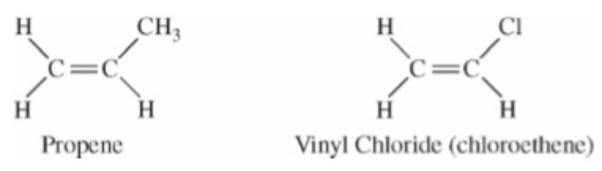
- Answer the questions that follow about propene (CH₂CHCH₃) and vinyl chloride (CH₂CHCl), shown above.
  - Identify the intermolecular forces present in each molecule.

  - The boiling point of liquid propene (226 K) is lower than the boiling point of liquid vinyl chloride (260 K). Account for this difference in terms of the types and strengths of intermolecular forces present in each liquid.
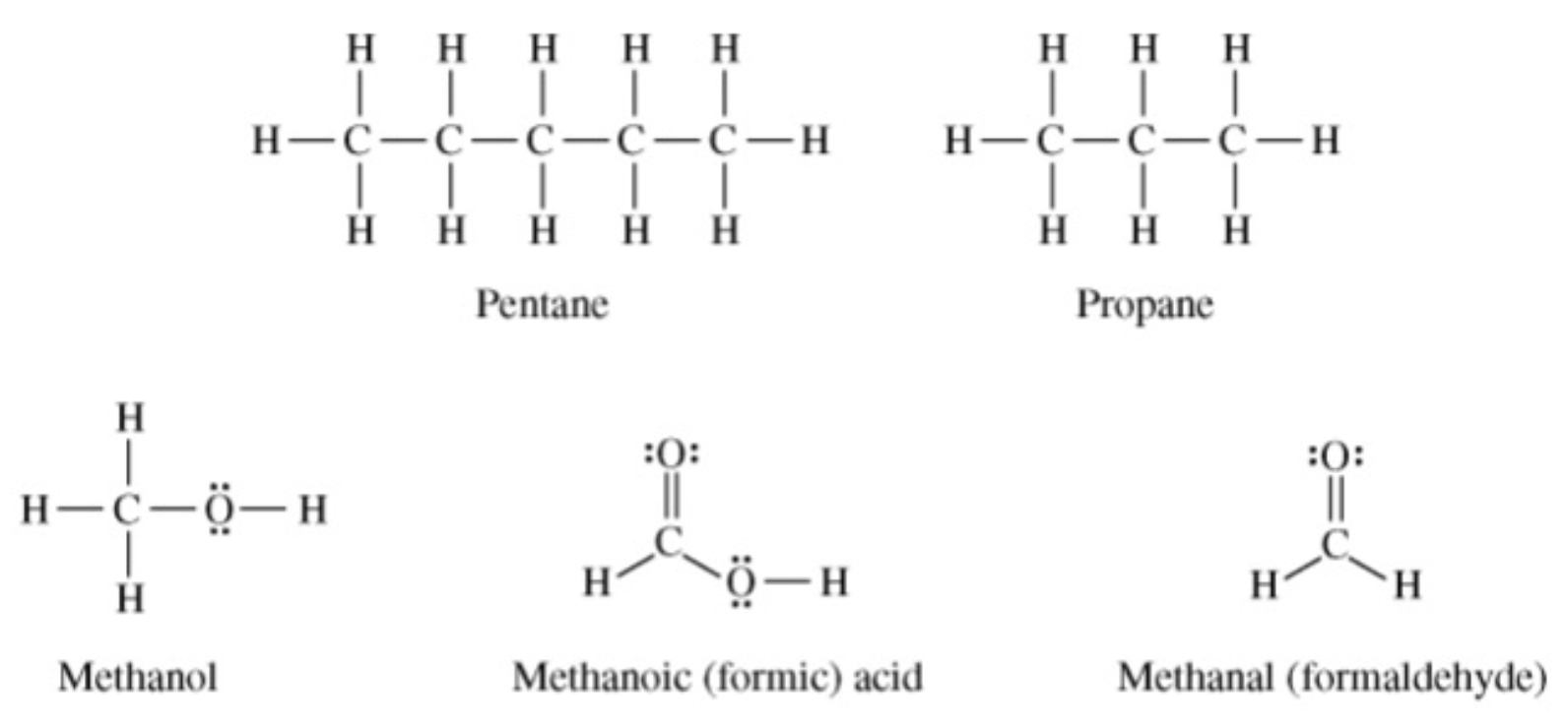

- Answer the following questions in terms of principles of chemical bonding and intermolecular forces. In each explanation where a comparison is to be made, a complete answer must include a discussion of both substances. The following complete Lewis electron-dot diagrams may be useful in answering parts of this question.
  - At 1 atm and 298 K, pentane is a liquid whereas propane is a gas. Explain.

  - At 1 atm and 298 K, methanol is a liquid whereas propane is a gas. Explain.

  - 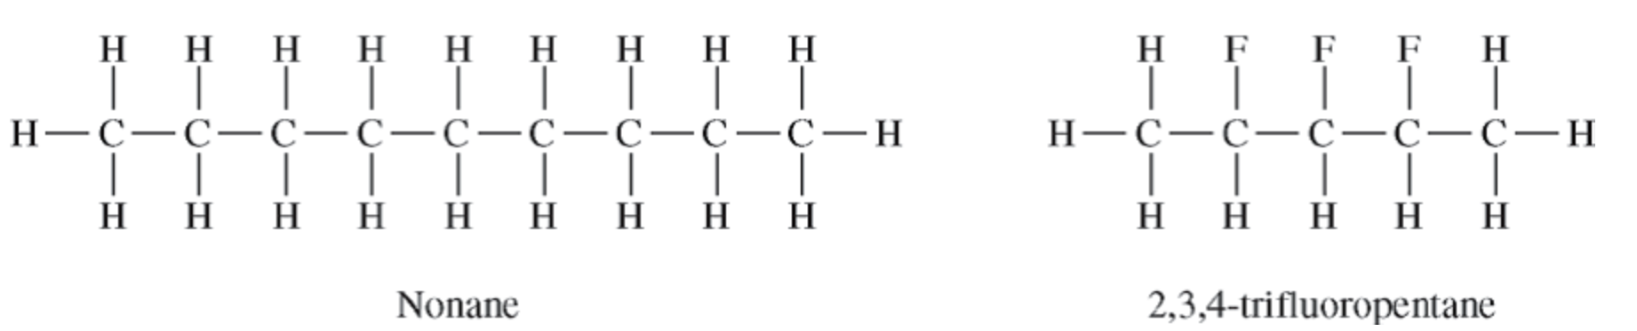

- Shown above are the Lewis structures for nonane and 2,3,4-trifluoropentane.
  - Identify the intermolecular forces present in both molecules.

  - Nonane has a higher boiling point than 2,3,4-trifluoropentane even though they have nearly identical molar masses. Which substance, nonane or 2,3,4-trifluoropentane, has the stronger intermolecular forces? Justify your answer.

- Energy is required to boil ethanol. Consider the statement “As ethanol boils, energy goes into breaking C – C bonds, C – H bonds, C – O bonds, and O – H bonds.” Is the statement true or false? Explain your answer.

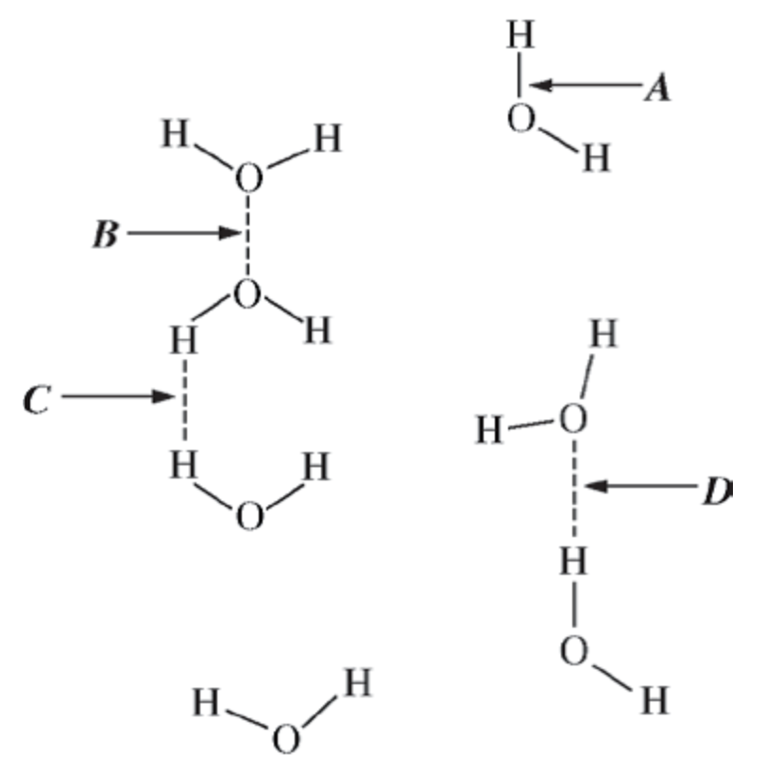
8. Use the figure above to answer the questions that follow.
  - What does arrow A indicate?

  - Arrow D indicates a hydrogen bond. Explain why D indicates a hydrogen bond while B and C do not.

