NAME: HONORS CHEMISTRY
SECTION: Chapter 11 Review Sheet

After studying chapter 11.1-11.10, you should be able to:
- Discuss the dual wave-particle nature of light.
- Explain and calculate the relationship between frequency, wavelength, and energy of light.
- Compare and contrast the Bohr model and the quantum model of the atom.
- Characterize the four quantum numbers, and use quantum numbers to describe electrons in atoms.
- Relate the number of sublevels corresponding to each of an atom’s main energy levels, the number of orbitals per sublevel, and the number of orbitals per main energy level.
- Apply the Aufbau principle, the Pauli Exclusion Principle, and Hund’s rule to write the electron configurations of the elements.
- Explain the origin of the atomic emission spectrum of an element.
- Write Lewis dot diagrams to represent the valence electrons of main-block elements.
- Identify the s, p, d and f blocks of the periodic table.

Problems for you to try

- What do we mean when we say that light and electrons exhibit a wave-particle duality?

- What is the frequency of radiation whose wavelength is 4.50 x 10⁻⁵ cm? What is the energy of a single photon of this radiation? In what region of the electromagnetic spectrum would it be located?

- Which transition has the greatest energy? The lowest energy?

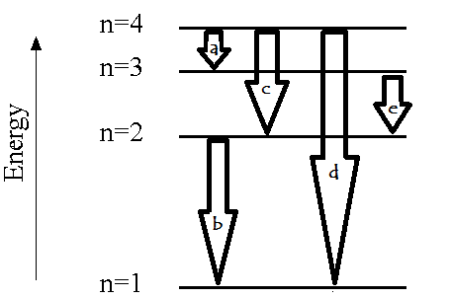
- Which wave shown below resulted from the larger quantum jump (i.e., electron transition between allowed energy levels)? Explain how you arrived at your answer.

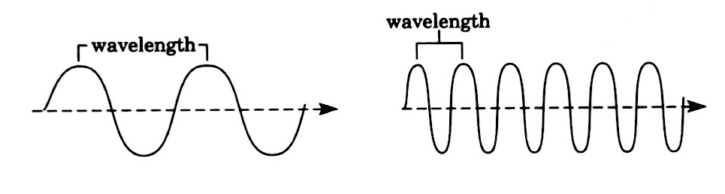

- Explain how electrons change energy levels to produce emission spectra. Include a discussion of why only certain colors of light are observed. You should include a diagram of energy levels with your answer.

- How many different energy quanta were released by the element that produced the spectrum shown below? How do you know this?

- Define the four quantum numbers n, l, m, and s, explain what information is given by each, and describe the range of values each may take.

- Generate a list of all the allowed values of quantum numbers l, m and s for energy level 3 (n = 3).

ℓ = | ℓ = | ℓ =

- Sketch an s orbital, a p orbital, and a d orbital.

- Complete the following table.
Sublevel | Number of orbitals | Maximum # of electrons in sublevel
s
p
d
f

- Explain the three rules for writing electron configurations.

- Using arrows and boxes (orbital notation), write electron configurations for:
  - P

  - Y

- Using noble gas notation, write electron configurations for:
  - F

  - Sr

- Identify the elements that have the following electron configurations:
  - 1s² 2s² 2p⁶ 3s² 3p³

  - 1s² 2s² 2p⁶ 3s² 3p⁶ 4s² 3d¹⁰ 4p⁶

  - 1s² 2s² 2p⁶ 3s² 3p⁶ 4s² 3d⁶

- Explain why the 4s sublevel fills before the 3d sublevel begins to fill as electrons are added.

- Write Lewis dot diagrams for the following elements:

  - Ca
  - As
  - Cl
  - Ge
  - Kr
  - Rb

- Which of the following statements of the modern model of the atom are true, and which are false?
- The probability of finding an electron is the same in any location within an orbital.
- An electron will probably spend most of its time close to the nucleus.
- Electrons travel in circular orbits around the nucleus.

- Which of the following statements about an orbital are true and which are false?
- An electron will be found inside an orbital 90% of the time.
- An electron travels around the surface of an orbital.
- An electron cannot be found outside an orbital.

