Name: __________________________--

**Electromagnetic Spectrum**

*Before watching the video:*

1. Take about 2 minutes to do a quick write/quick draw of the first things that come to your mind when you hear the words “color” and “light.”

*Answer the following questions as you watch the video:*

[*https://teachchemistry.org/classroom-resources/the-electromagnetic-spectrum-animation*](https://teachchemistry.org/classroom-resources/the-electromagnetic-spectrum-animation)

Write **T** for true or **F** for false next to each statement. If it is false, write a correct statement underneath.

1. _____ White light is a combination of all colors of the rainbow.
2. _____ Different colors of light all have the same wavelength.
3. _____ Longer wavelengths of light have more energy.
4. _____ Longer wavelengths of light have lower frequency.
5. _____ Red light has the most energy.
6. _____ Red light has the longest wavelength.
7. _____ Red light has the highest frequency.
8. _____ The colors we see are the wavelengths that are absorbed by an object.
9. _____ The visible spectrum is a very small part of the electromagnetic spectrum.
10. _____ Microwaves have less energy than visible light.

*After watching the video:*

1. Besides visible light, what are the other sections of the electromagnetic spectrum?
2. Which sections are higher in energy than visible light? Which section are lower in energy?

**Let's review the concept of light as a wave.**

• Light can be described as a combination of oscillating electric and magnetic fields that

propagate through space as a **wave**.

• An example of a wave is the familiar sine and cosine functions.

***Model 1****: A typical wave (a sine function)*

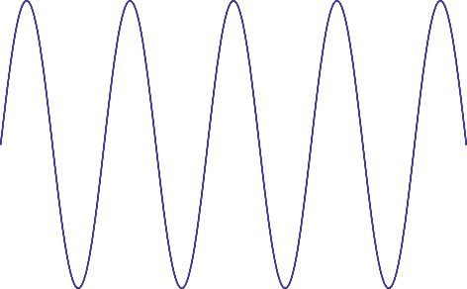

***Information***

• One important property of a wave is its wavelength.

• Being a length, the wavelength of a wave would have units of distance. For visible light,

the tradition is to use nanometers as the unit. (1 nm = 1 x 10-9 m)

• A wavelength is the length of the smallest repeating unit of a wave. This can be

measured from node to node, peak to peak, or trough to trough.

o A node is found graphically when the wave crosses the x-­‐axis.

• The symbol for wavelength is the Greek letter lambda, λ.

*designated by the dashed line. In panel F, the wavelength is also displayed.*

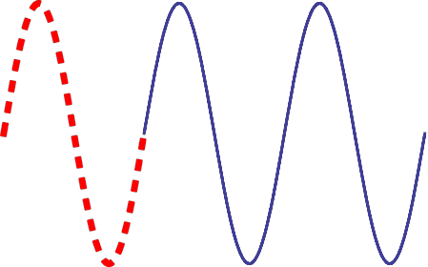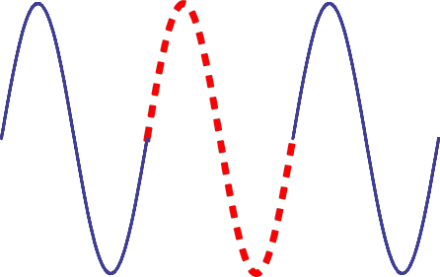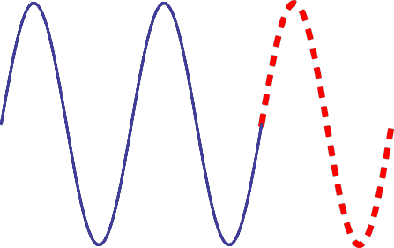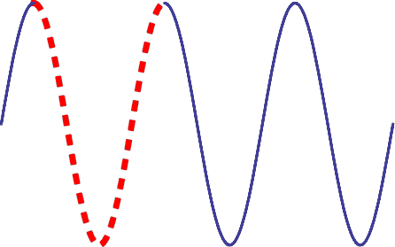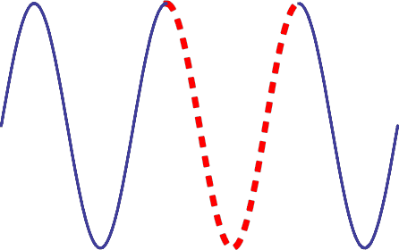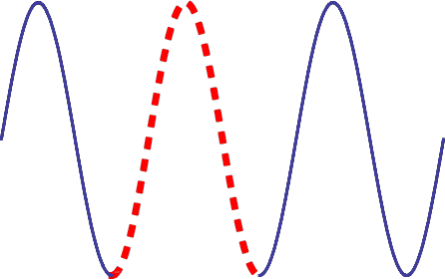

**A D**

**B E**

**C F**



λ

***Critical Thinking Questions***

14. In chemistry and physics, what symbol do we use to represent the wavelength of any wave? What is the base unit utilized for this property of waves?

15. In model 2, list all the sample waves where the highlighted cycle (dashed portion)

extends from node-­‐to-­‐node.

16. In model 2, list all the sample waves where the highlighted cycle (dashed portion)

extends from peak-­‐to-­‐peak.

extends from trough-­‐to-­‐trough.

18. How many cycles are represented in model 1?

19. On model 1, draw an arrow that represents the first peak to peak wavelength.



***Information***

• The frequency of a wave is a measure of how many cycles of the wave pass by a specific point in a single second.

o The units for frequency are thus cycles per second, usually expressed as s-1, 1/s

or Hz, where Hz stands for Hertz (pronounced ‘hurts’)

• The symbol used for frequency is the Greek letter nu (‘new’), .

• In model 1, there are 4.5 cycles displayed. If this wave passed by in 2 seconds, the frequency would be 2.25 Hz.

***Critical Thinking Questions***

20. Confirm that ν = 2.25 *Hz* for the wave in model 1, given that the entire wave pictured passed by in 2 seconds. Show your work.

21. Consider the wave displayed in Model 2, which passes by in 12.3 seconds.

a. How many cycles does the wave have?

b. What is the frequency of the wave?

*beneath. Only the relevant portion of the ruler is displayed.*

*beneath. Only the relevant portion of the ruler is displayed*

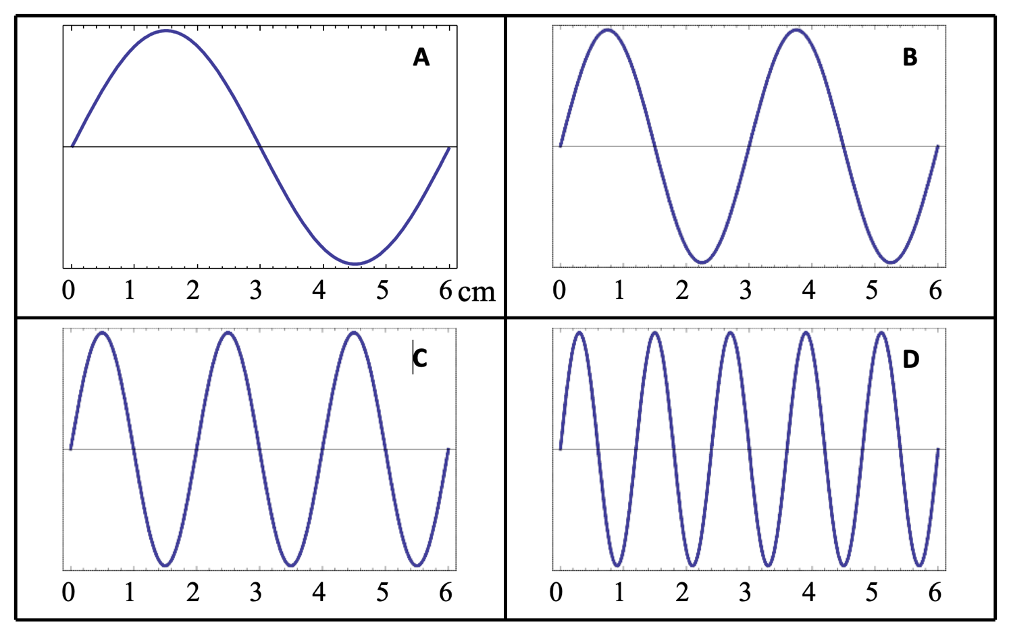

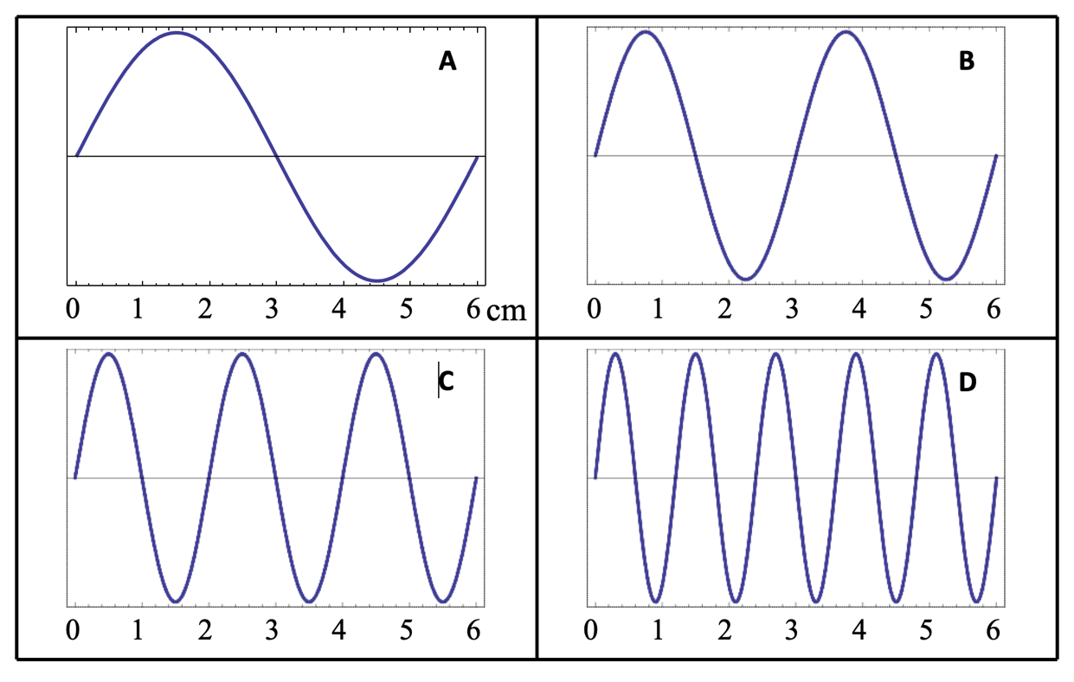

***Critical Thinking Questions***

22. Each of the waves (A-­‐D) in Model 3 passed by an observer in the same time period. Which of the waves has the highest frequency?

23. Which of the waves (A-­‐D) has the longest wavelength? What is that wavelength? Include units with your answer.

24. Complete the following table, assuming that the each of the waves in Model 3 passed by in

0.025 seconds.

|  |  |  |  |  |
| --- | --- | --- | --- | --- |
| Wave | # cycles | Frequency (s-1) | Wavelength (cm) | λ *×*  |
| A |  |  |  |  |
| B |  |  |  |  |
| C |  |  |  |  |
| D |  |  |  |  |

25. What units did you use for the far-right column (λ *×* ) in CTQ11?

26. What physical quantity has the units of CTQ 12?

***Information***

• The speed (velocity) of any wave is determined by the product of wavelength and frequency.

• For water waves in the ocean or seismic waves through land, the velocity of the wave can differ depending upon the amount of energy contained in the wave motion.

• Light always travels at the same, finite speed, given the symbol c. c = 299,728,458 m/s, or

3.00×108m/s. You do not need to memorize this constant.

• The speed of light represents the cosmic speed limit and nothing can travel faster than c.

• λ ***×***  ***= c*** for electromagnetic radiation…*this relationship should be memorized*

27. Rearrange λ *×*  *= c* to solve for the frequency.



28. A typical radio wave has a wavelength of 3.0 m. What is the frequency of a typical radio wave?

***Information***

* Experiments show that light behaves like a wave.

• Other experiments show that light behaves like a particle and exists in discrete, small bundles called **photons**. Max Plank discovered that photons each have an energy, which he called a *quanta* of energy. Light is thus “quantized” because it can be described in terms of individual energy of the photons.

• The energy of a photon is related to the frequency of the light by *E = h* , where *h* is

Plank’s constant. *h = 6.626×10-­‐34J·∙s*. You do not need to memorize this constant.

***Critical Thinking Questions***

29. If the frequency of a photon is somehow increased, does the energy increase, decrease, or stay the same? Explain your reasoning.

30. Would you say that the energy of a photon is directly proportional, inversely proportional, or not related to the frequency?

31. Substitute your answer to question #27 into Plank’s energy relationship to show a relationship between the energy of a photon and the wavelength of a photon.

32. If the wavelength of a photon were somehow increased, does the energy increase, decrease, or stay the same? Explain your reasoning.

33. Would you say that the energy of a photon is directly proportional, inversely proportional, or not related to the wavelength?

Information

• As mentioned in the video, there are many types (or flavors) of light that differ in energy and the affect it has on matter.

o The electromagnetic spectrum listed in order from lowest to highest energy is radio,

microwave, infrared, visible, ultraviolet, X-­‐ray and Gamma ray (γ-­‐ray)

o Visible light is further subdivided into Red, Orange, Yellow, Green, Blue, Indigo and

Violet (ROYGBIV), also given in increasing energy.





***Critical Thinking Questions***

34. Without calculating anything, which type of light listed below has the highest energy? Circle your answer.

X-­‐rays Infrared (IR) Ultraviolet (UV) Green

35. Without calculating anything, which type of light listed below has the highest frequency? Circle your answer.

Ultraviolet (UV) Green X-­‐rays Infrared (IR)

36. Without calculating anything, which type of light listed below has the longest wavelength? Circle your answer.

Green Infrared (IR) X-­‐rays Ultraviolet (UV)

***Extension Questions***

***Information***

• The brightness of light is a measure of how many photons are hitting a certain area at a time.

• Bright light contains more energy because there are more photons, not because the photons are necessarily more energetic.

• In the wave model, brighter light has a larger amplitude (height) than dim light.

Model 5

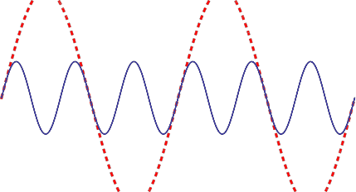

37. In model 5, does the solid or dashed line represent the wave with highest frequency?

38. In model 5, does the solid or dashed line represent the wave with the highest energy?

3