NAME: HONORS CHEMISTRY
SECTION: Potential Energy Diagrams

1. Answer the following questions based on the potential energy diagram shown here:
- Does the graph represent an endothermic or exothermic reaction?

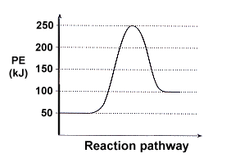
- Label the position of the reactants, products, and transition state.

- Determine the heat of reaction, ΔH, (enthalpy change) for this reaction.

- Determine the activation energy, E_{a}, for the forward reaction.

- Draw a dashed line to show the effect of adding a catalyst to the system.

- What is the value of the potential energy of the activated complex?

2. Sketch a potential energy curve that is represented by the following values of ΔH and E_{a} as large as you can in the space provided. You may make up appropriate values for the y-axis (potential energy). Label the x axis as “reaction progress”

ΔH = -100 kJ and E_{a} = 20 kJ

Is this an endothermic or exothermic reaction?

3. In the next unit we will be discussing reactions that are reversible, and can go in either the forward or reverse directions. For example, hydrogen gas and oxygen gas react to form water, but water can also be broken down into hydrogen and oxygen gas.
We typically write a reaction that can be reversed this way, using the double arrow symbol ( or ↔ or ):

2 H₂ + O₂ ↔ 2 H₂O
This reaction is exothermic in the forward direction: 2 H₂ + O₂ → 2 H₂O + 285 kJ

but endothermic in the reverse direction: 2 H₂O + 285 kJ → 2 H₂ + O₂
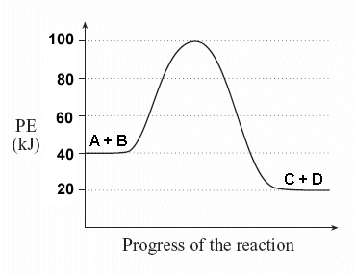
Consider a general reversible reaction such as:

A + B ↔ C + D

Given the following potential energy diagram for this reaction, determine ΔH and E_{a} for both the forward and reverse directions.

Is the forward reaction endothermic or exothermic?

4. Sketch a potential energy diagram for a general reaction A + B↔C + D

Given that ΔH_{reverse} = -10 kJ and
E_{a} forward = +40 kJ
(select your own values for the y axis)

5. Draw a potential energy diagram for the following reaction: Q + R → S + T

The potential energy of Q + R is 250 kJ; the potential energy of S + T is 150 kJ; and the potential energy of the activated complex is 375 kJ.

