NAME: HONORS CHEMISTRY
SECTION: Reading Manometers

There are two types of manometers. In the open type, air exerts pressure on the column of liquid in one arm of the U-tube, and the gas sample exerts pressure on the other arm. The difference in liquid level between the two arms is a measure of the gas pressure relative to the atmospheric pressure. The closed type has a vacuum above the liquid in one arm.

1. P_{atm} = 755 mm Hg 2 3
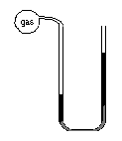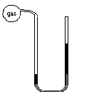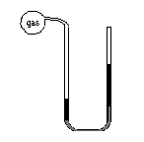
325
mm
Hg
200.
mm
Hg
650
mm
Hg
90
mm
Hg
236
mm
Hg
314
mm
Hg

4 5 6 P_{atm} = 747 mm Hg
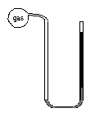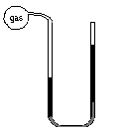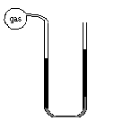
350.
mm
Hg
300.
mm
Hg
720
mm
Hg
340
mm
Hg
480
mm
Hg
10
mm
Hg

7 P_{atm} = 740. mm Hg 8 P_{atm} = 775 mm Hg 9
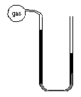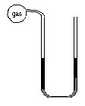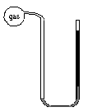
30.
mm
Hg
600.
mm
Hg
250
mm
Hg
250
mm
Hg
275
mm
Hg
400.
mm
Hg

