NAME: **HONORS CHEMISTRY**

SECTION: Introducing Molarity

Question: How can the concentration of a solution be expressed quantitatively in terms of moles?

Have you ever had a fountain drink that tasted a little “off” because the soda dispenser used too much or too little flavoring syrup? If your doctor prescribes a cough medicine, you expect that every teaspoon will have the same amount of active ingredient. How do companies ensure that their products taste or perform the same every time you purchase them? They pay close attention to the ratio of components in the mixture and monitor it closely.

Part 1: Reviewing Solutions

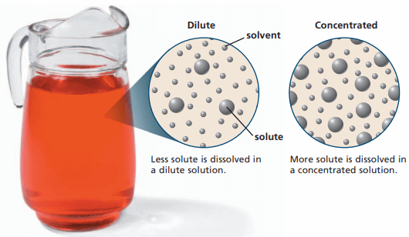

1. How are solute particles represented in this model?
2. How are solvent particles represented in this model?
3. How can you differentiate between dilute and concentrated solutions?

Dilute vs concentrated

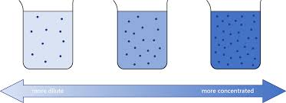

1. Do the terms “dilute” and “concentrated” provide any specific information about the quantities of solute or solvent in a solution? Explain.



Last week we learned about percent solutions as one way to describe the solute:solvent ratio in a solution. Today we will learn about the concentration unit used most in chemistry, and every chemist’s favorite way to discuss solution concentration—**molarity**! As you can probably tell from the name, this concentration unit involves moles (the chemical quantity, not little furry animals).

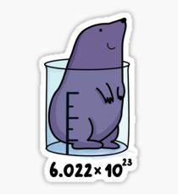

**Part 2: The Molarity Formula**

$M= \frac{moles of solute}{solution volume in L}$

Example: 1.5 moles of sodium chloride are dissolved in enough water to make 0.50 L of solution.

$M= \frac{1.5 moles NaCl}{0.50 L}=3.0 M NaCl$

* 3.0 M is read as “three point oh molar”
* Since molarity is calculated based on measured quantities, it is always reported with significant figures.

1. What symbol is used to represent molarity? (Capitalization matters)
2. Rearrange the molarity formula to solve for the volume of the solution in liters.
3. Rearrange the molarity formula to solve for moles of solute.

Lab balances do not measure in moles—that’s not a quantity we can measure directly. Instead we measure the mass of the solute in grams. Fortunately we already know how to convert between mass and moles:

$$moles= \frac{grams}{molar mass}$$

1. Substitute the expression above into the molarity equation.
2. Rearrange the equation you wrote in question 8 to solve for mass of the solute.



Volumes of solutions are often measured in milliliters, not liters. Be prepared to convert!

1. How many milliliters are in a liter?

**Part 3: Molarity Problems**

Show all your work. Report your answers with the correct number of significant figures and an appropriate unit. You will need a calculator and a periodic table.

Level 1

1. Calculate the molarity of a solution containing 0.35 moles of potassium sulfate in a total volume of 0.25L.
2. How many moles of sucrose, C12H22O11, are needed to prepare 2.00L of a 0.750 M solution?
3. A student has 0.42 moles of potassium chloride. What volume (in L) of 0.75M solution can the student prepare?



Level 2

1. What is the molarity of a solution containing 12.2 g of ammonium chloride, NH4Cl, in a final volume of 95.0 mL?

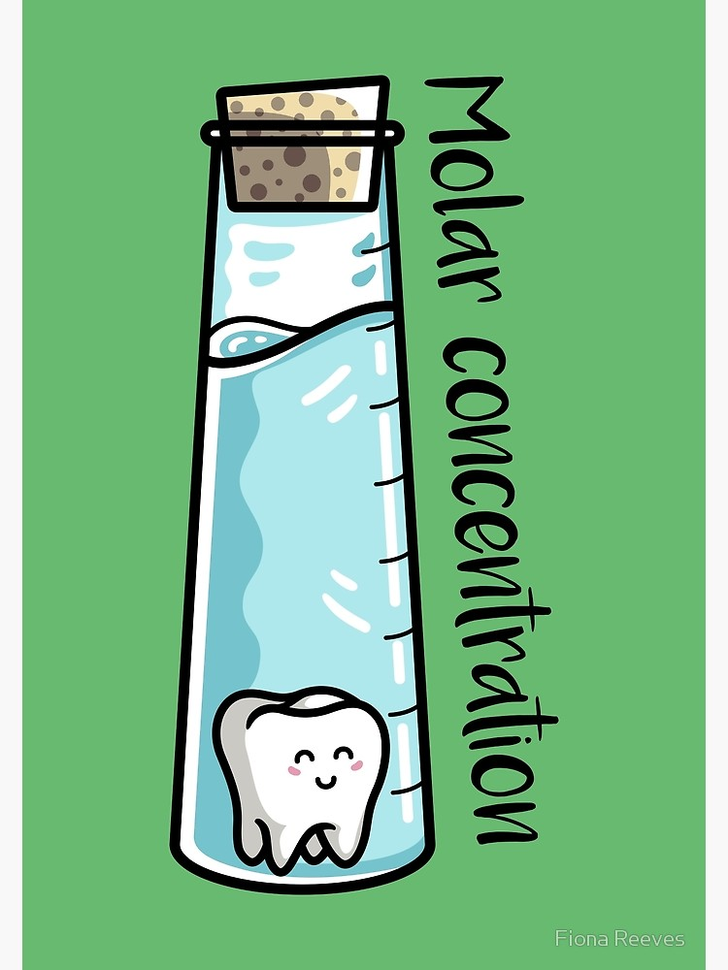

1. You have a 1.2 M solution of sodium chlorate, NaClO3. If you need 0.34 moles of sodium chlorate for a reaction, what volume of solution (in mL) should you measure out?
2. How many grams of calcium chloride, CaCl2, are needed to prepare 225 mL of a 0.060 M solution?



Level 3

1. Calculate the molarity of a solution prepared from 19.7 g of magnesium nitrate, brought to a final volume of 850 mL.
2. What mass of sodium carbonate is required to prepare 2300 mL of a 0.040 M solution.



**Additional Notes**

When preparing solutions of a particular molarity, we find the mass of the solute, then dissolve in a small amount of water and then transfer the solution to a volumetric flask. Add enough water to bring the meniscus to the line of the volumetric flask. (If less precision is needed, then you may find the final volume in a graduated cylinder. )

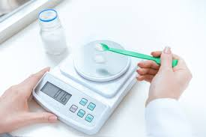 + 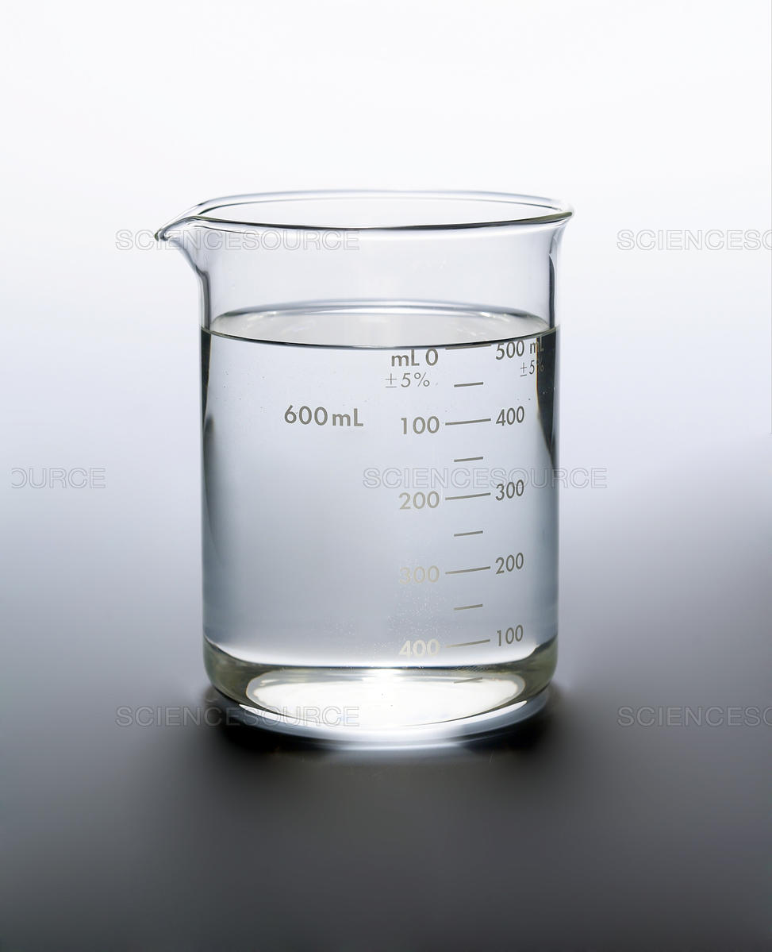 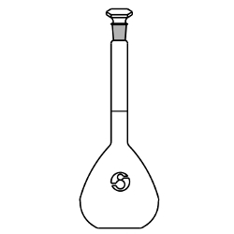

You cannot use the volume of just the solvent, because the volume after mixing the two components may not be the same as the volume of the solvent alone.